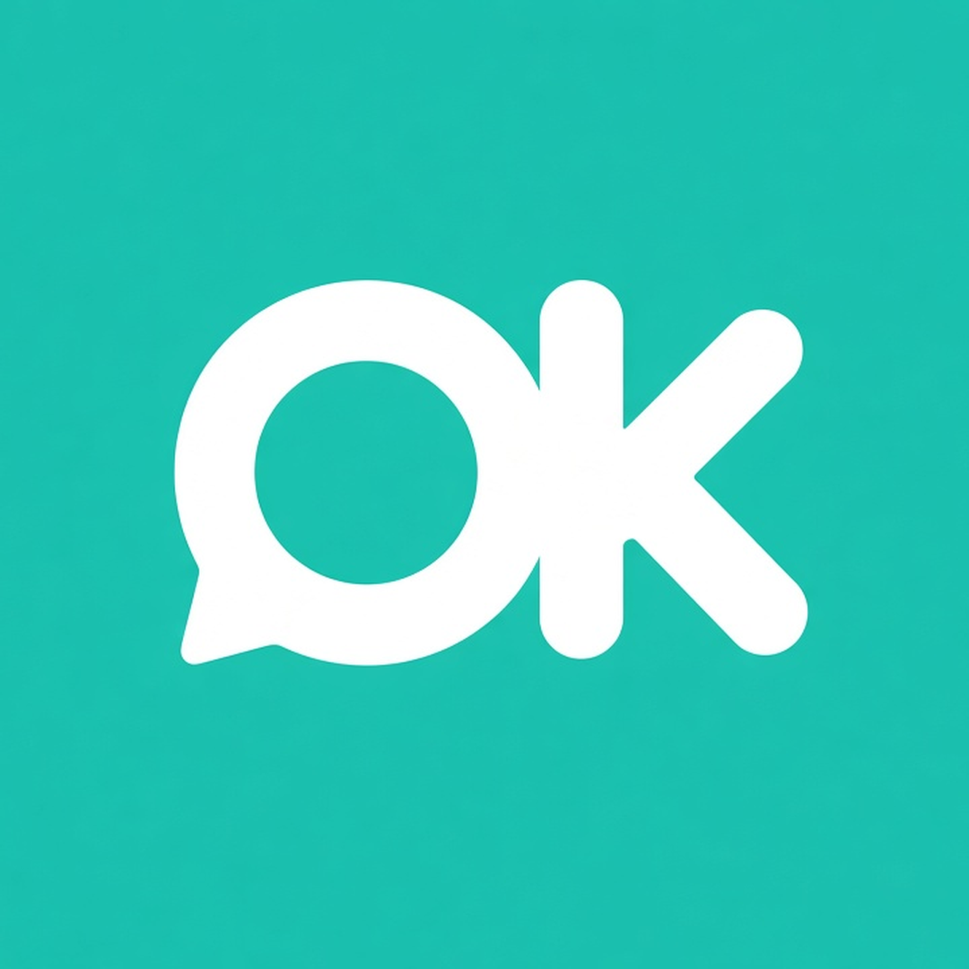
Deposit & cancellation policy template
How to use: replace everything in [brackets], delete anything that doesn't apply, then pin it on your menu post or send it with every order summary. This template is a friendly starting point, not legal advice. Keep it short, clear and kind, and apply it the same way to everyone.
[Your bakery name] · Festive pre-order policy
Thank you for ordering with us! We bake every order fresh in small batches, so we plan ingredients and oven time around confirmed orders. Here's how it works.
1. Placing your order
Orders open on [open date] and close on [cut-off date, time], or when we're sold out, whichever comes first. To order, send us your name, phone number, items and quantity, pickup or delivery, and your preferred slot.
2. Deposit to confirm
To confirm your order, please pay a [__]% deposit by PayNow to [PayNow number or UEN, account name] within [__ hours] of our order summary. Please put your order number in the PayNow reference. Your order is confirmed once we see the payment in our bank account, and we'll message you to let you know. Orders without a deposit after [__ hours] will be released to the next customer.
3. Balance
The balance is due [by (date) / at pickup, before handover], by PayNow with your order number as the reference[ or in cash]. We check every payment in our bank app before handing over your order.
4. Changes
You can change items or quantities until [date], and your pickup slot until [date], subject to availability.
5. Cancellations and refunds
• Cancel by [date]: [full deposit refund / deposit refunded less S$__ / store credit for a future order].
• Cancel after [date]: the deposit is non-refundable, as ingredients have been bought and your batch planned.
• If we need to cancel (for example, illness or an oven breakdown), we'll refund everything you've paid in full.
6. Pickup
Pickup is at [area or block, exact directions sent the day before] during the slot you chose. Pickups run back to back, so please come on time. Running late? Just message us.
7. Late pickup and no-shows
If you're more than [__] minutes late, we'll [hold your order until (time) / move you to the next free slot]. If an order isn't collected by [date, time] and we haven't heard from you, it counts as a no-show: [the deposit / the full amount] is non-refundable, and we can't hold fresh bakes beyond [date].
8. Delivery (if offered)
Delivery is S$[__] to [areas], within a [__] window. Someone needs to be home to receive it. Re-delivery after a failed attempt is S$[__].
9. Allergens and storage
Our bakes are made in a home kitchen that also handles [nuts, peanuts, eggs, dairy, wheat/gluten, soy, sesame, other]. We can't guarantee any item is free from allergens, so please tell us about allergies before you order. Storage: [keep in an airtight container, away from heat; best enjoyed within __ days].
10. Agreeing to this policy
Paying the deposit means you've read and agreed to this policy. Thank you for supporting a small home business!

Copy-paste WhatsApp messages
Save these as Quick Replies (WhatsApp Business) or in your phone notes. Swap the [brackets] for real details.
1. Order confirmation + deposit request
Hi [Name]! Thank you for your order 🧁 Here's what I've got down:
Order no: [CNY-012]
• [2] x [Pineapple tarts, 50 pcs tub]
• [1] x [Kueh bangkit tub]
Total: S$[__]
Pickup: [Sat 30 Jan, 2–3pm] at [area]
To confirm, please PayNow the deposit of S$[__] to [number/UEN, name] by [date, time], and put [CNY-012] in the reference. Once I see it in my bank account, I'll message you to confirm. Balance of S$[__] is due [at pickup / by date].
Policy: [link or "see below"]. Any allergies I should know about?
2. Payment received
Hi [Name], received your deposit of S$[__] for order [CNY-012], thank you! ✅
Your order is confirmed:
Pickup: [Sat 30 Jan, 2–3pm] at [area]
Balance: S$[__], due [at pickup / by date]
I'll send a reminder the day before. Any changes, just let me know by [date].
3. Pickup reminder (day before)
Hi [Name]! Friendly reminder that your order [CNY-012] is ready for pickup tomorrow:
📅 [Sat 30 Jan], [2–3pm]
📍 [address / directions]
💳 Balance S$[__] by PayNow to [number] with [CNY-012] as reference [or cash]
Running late? Just drop me a message so I can plan. See you! 🍍
Bonus: gentle deposit nudge
Hi [Name]! Just checking in on order [CNY-012] 😊 I'm holding your [items] until [date, time]. If you'd still like it, please PayNow the S$[__] deposit with [CNY-012] as reference. If plans have changed, no worries at all, just let me know so I can offer the slot to someone else.
Bonus: thank you + next menu
Hi [Name], thank you so much for ordering with us this CNY! 🧧 Hope the family enjoyed them. If you have a moment, a quick review or photo would really help a small home bakery like ours: [review link]. Can I add you to our list for our [Raya / next festive] menu?
Bonus: orders closed
Hi [Name], thank you for asking! Our CNY orders are fully booked for this year 🙏 Want me to message you when our [Raya / next] menu is out?
Tips
- Send the order summary before asking for payment, so customers can spot mistakes early.
- One order no. per customer (e.g. CNY-001, CNY-002), used in your message, the PayNow reference and your tracker.
- Confirm an order only after the deposit shows in your bank app, not just a screenshot.
- Keep your policy link in your WhatsApp Business profile or pinned on your menu post.
Want less admin next festive season? OrderKaki is an owner app for home bakers, built to bring order links, batch caps, pickup slots and payment checks into one place. Join early access (free during early access): orderkaki.pages.dev · Follow @orderkaki on TikTok & IG

